2017 ICM

Problem D: **Optimizing the Passenger Throughput at an Airport Security Checkpoint**

Following the terrorist attacks in the US on September 11, 2001, airport security has been significantly enhanced throughout the world. Airports have security checkpoints, where passengers and their baggage are screened for explosives and other dangerous items. The goals of these security measures are to prevent passengers from hijacking or destroying aircraft and to keep all passengers safe during their travel. However, airlines have a vested interest in maintaining a positive flying experience for passengers by minimizing the time they spend waiting in line at a security checkpoint and waiting for their flight. Therefore, there is a tension between desires to maximize security while minimizing inconvenience to passengers.

During 2016, the U.S. Transportation Security Agency (TSA) came under sharp criticism for extremely long lines, in particular at Chicago’s O’Hare international airport. Following this public attention, the TSA invested in several modifications to their checkpoint equipment and procedures and increased staffing in the more highly congested airports. While these modifications were somewhat successful in reducing waiting times, it is unclear how much cost the TSA incurred to implement the new measures and increase staffing. In addition to the issues at O’Hare, there have also been incidents of unexplained and unpredicted long lines at other airports, including airports that normally have short wait times. This high variance in checkpoint lines can be extremely costly to passengers as they decide between arriving unnecessarily early or potentially missing their scheduled flight. Numerous news articles, including [1,2,3,4,5], describe some of the issues associated with airport security checkpoints.

Your Internal Control Management (ICM) team has been contracted by the TSA to review airport security checkpoints and staffing to identify potential bottlenecks that disrupt passenger throughput. They are especially interested in creative solutions that both increase checkpoint throughput and reduce variance in wait time, all while maintaining the same standards of safety and security.

The current process for a US airport security checkpoint is displayed in **Figure 1**.

• **Zone A:**

o Passengers randomly arrive at the checkpoint and wait in a queue until a security officer can inspect their identification and boarding documents.

• **Zone B:**

o The passengers then move to a subsequent queue for an open screening line; depending on the anticipated activity level at the airport, more or less lines may be open.

o Once the passengers reach the front of this queue, they prepare all of their belongings for X-ray screening. Passengers must remove shoes, belts, jackets, metal objects, electronics, and containers with liquids, placing them in a bin to be X-rayed separately; laptops and some medical equipment also need to be removed from their bags and placed in a separate bin.

o All of their belongings, including the bins containing the aforementioned items, are moved by conveyor belt through an X-ray machine, where some items are flagged for additional search or screening by a security officer (Zone D).

o Meanwhile the passengers process through either a millimeter wave scanner or metal detector.

o Passengers that fail this step receive a pat-down inspection by a security officer (Zone D).

• **Zone C:**

o The passengers then proceed to the conveyor belt on the other side of the X-ray scanner to collect their belongings and depart the checkpoint area.

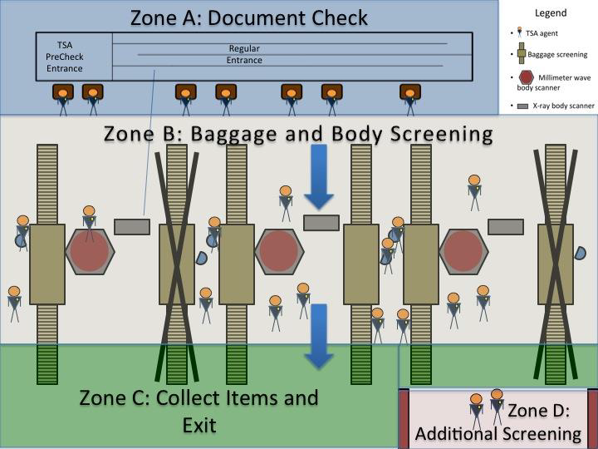

**Figure 1:** Illustration of the TSA Security Screening Process.

Approximately 45% of passengers enroll in a program called Pre-Check for trusted travelers. These passengers pay $85 to receive a background check and enjoy a separate screening process for five years. There is often one Pre-Check lane open for every three regular lanes, despite the fact that more passengers use the Pre-Check process. Pre-Check passengers and their bags go through the same screening process with a few modifications designed to expedite screening. Pre-Check passengers must still remove metal and electronic items for scanning as well as any liquids, but are not required to remove shoes, belts, or light jackets; they also do not need to remove their computers from their bags.

Data has been collected about how passengers proceed through each step of the security screening process. Click here to view the Excel data.

Your specific tasks are:

a. Develop one or more model(s) that allow(s) you to explore the flow of passengers through a security check point and identify bottlenecks. Clearly identify where problem areas exist in the current process.

b. Develop two or more potential modifications to the current process to improve passenger throughput and reduce variance in wait time. Model these changes to demonstrate how your modifications impact the process.

c. It is well known that different parts of the world have their own cultural norms that shape the local rules of social interaction. Consider how these cultural norms might impact your model. For example, Americans are known for deeply respecting and prioritizing the personal space of others, and there is a social stigma against “cutting” in front of others. Meanwhile, the Swiss are known for their emphasis on collective efficiency, and the Chinese are known for prioritizing individual efficiency. Consider how cultural differences may impact the way in which passenger’s process through checkpoints as a sensitivity analysis. The cultural differences you apply to your sensitivity analysis can be based on real cultural differences, or you can simulate different traveler styles that are not associated with any particular culture (e.g., a slower traveler). How can the security system accommodate these differences in a manner that expedites passenger throughput and reduces variance?

d. Propose policy and procedural recommendations for the security managers based on your model. These policies may be globally applicable, or may be tailored for specific cultures and/or traveler types.

In addition to developing and implementing your model(s) to address this problem, your team should validate your model(s), assess strengths and weaknesses, and propose ideas for improvement (future work).

*Your ICM submission should consist of a 1 page Summary Sheet and your solution cannot exceed 20 pages for a maximum of 21 pages. Note: The appendix and references do not count toward the 20 page limit.*

**References:**

[1] http://www.wsj.com/articles/why-tsa-security-lines-arent-as-bad-as-youd-feared- 1469032116

[2] http://www.chicagotribune.com/news/ct-tsa-airport-security-lines-met-20160823- story.html

[3] http://www.cnn.com/2016/06/09/travel/tsa-security-line-wait-times-how-long/

[4] http://wgntv.com/2016/07/13/extremely-long-lines-reported-at-chicago-midway-airports-tsa-checkpoint/

[5] http://www.cnbc.com/2016/04/14/long-lines-and-missed-flights-fuel-criticism-of-tsa-screening.html